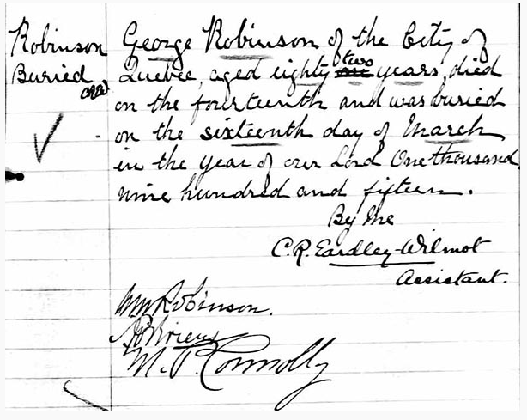

George Robinson’s burial record.

1915